Contents
Week 1: Installation and Configuration of Cryptography Development Environment 2
Fig 1: Installation of Python 2
2
Fig 2: Installation of Cryptography Libraries 2
Fig 3: OpenSSL Installation Test 3
3
Fig 4: Local Encryption and Decryption Script Execution 3
Week 2: Classical Cryptography and Cipher Design 4
Implementation of Classical Encryption Algorithms 4
1. Fig 1: Caesar Cipher Implementation,encryption and decryption results 4
2. Fig 2: Vigenère Cipher Encryption Process and the encryption and decryption results 5
3. Fig 3: User Input Validation Interface 6
4. Cipher Testing Results 6
a) Symmetric Encryption Layer (Fernet) 6
b) Caesar Substitution Cipher Layer 7
c) Polyalphabetic Substitution Layer (Vigenère) 7
Week 3: Stream Ciphers and Randomness Testing 8
Implementation of Stream Cipher Systems and Random Sequence Analysis 8
1. Fig 1: LFSR Generator Implementation and the results 8
2. Fig 2: Pseudorandom Sequence Output and the results 9
3. Fig 3: Statistical Randomness Testing and the results 10
4. Fig 4: RC4 Stream Cipher Simulation and the results 11
Week 4: Block Cipher Design and AES 12
Advanced Encryption Standard (AES) and Block Cipher Operations 12
1. Fig 1: AES Encryption Script 12
2. Fig 2: Key Generation Process 13
3. Fig 3: File Encryption Demonstration 16
4. Fig 4: Decryption Results 16
5. Fig 5: AES Performance Testing 17
17
Week 5: Public Key Cryptography (RSA) 17
Implementation of RSA Encryption and Key Management 17
1. Fig 1: RSA Key Pair Generation 17
2. Fig 2: Public Key Encryption Process 18
3. Fig 3: Private Key Decryption Results 18
4. Fig 4: Secure Message Transmission 19
5. Fig 5: RSA Testing and Validation 19
19

Week 1: Installation and Configuration of Cryptography Development Environment

Fig 1: Installation of Python

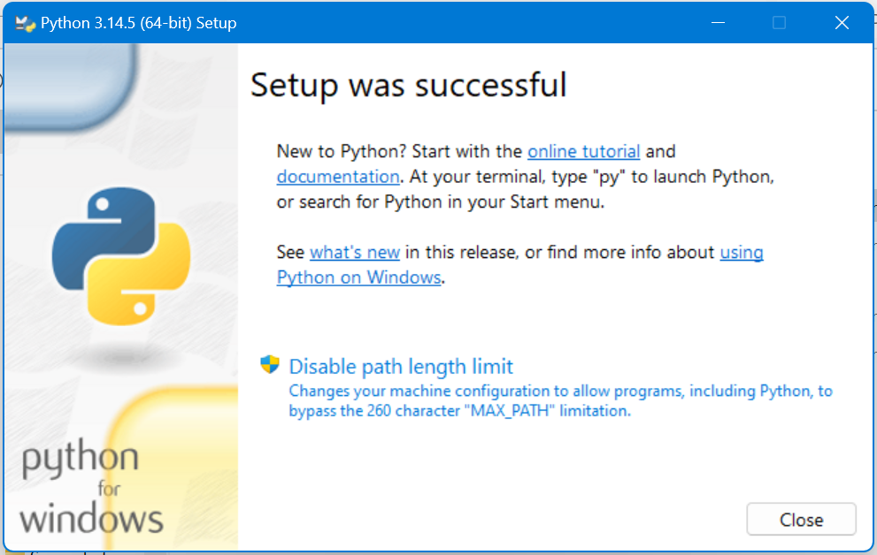

Fig 2: Installation of Cryptography Libraries

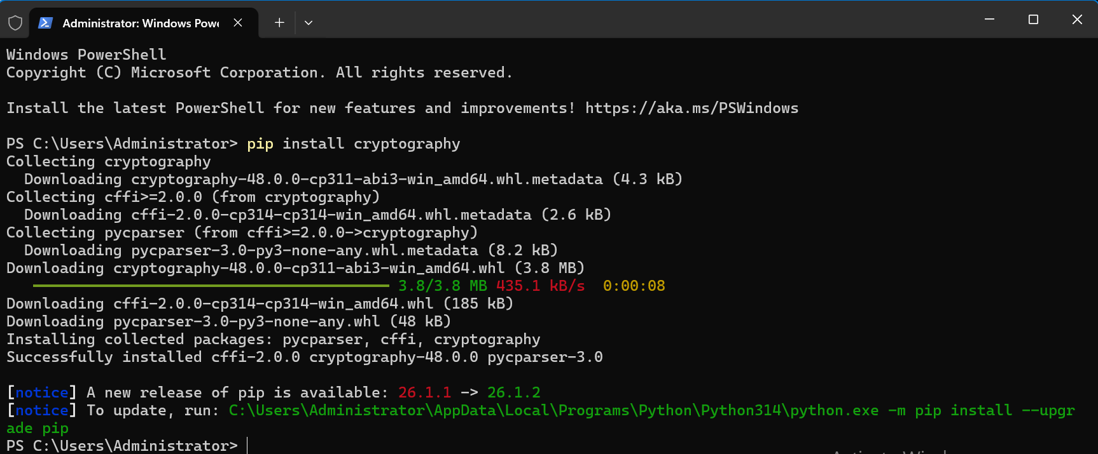

Fig 3: OpenSSL Installation Test

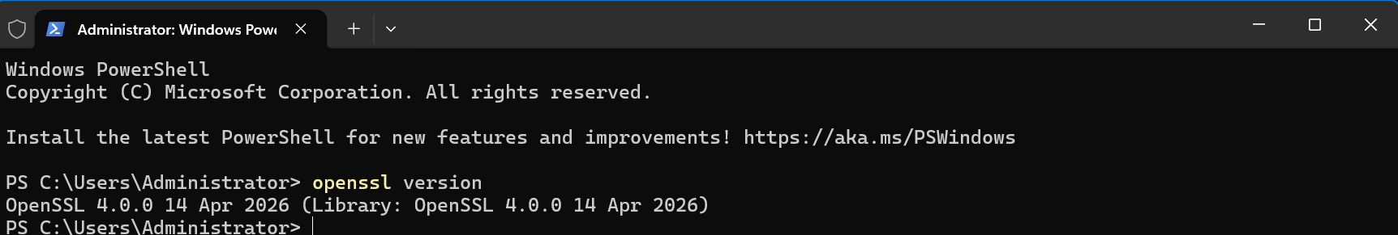

Fig 4: Local Encryption and Decryption Script Execution
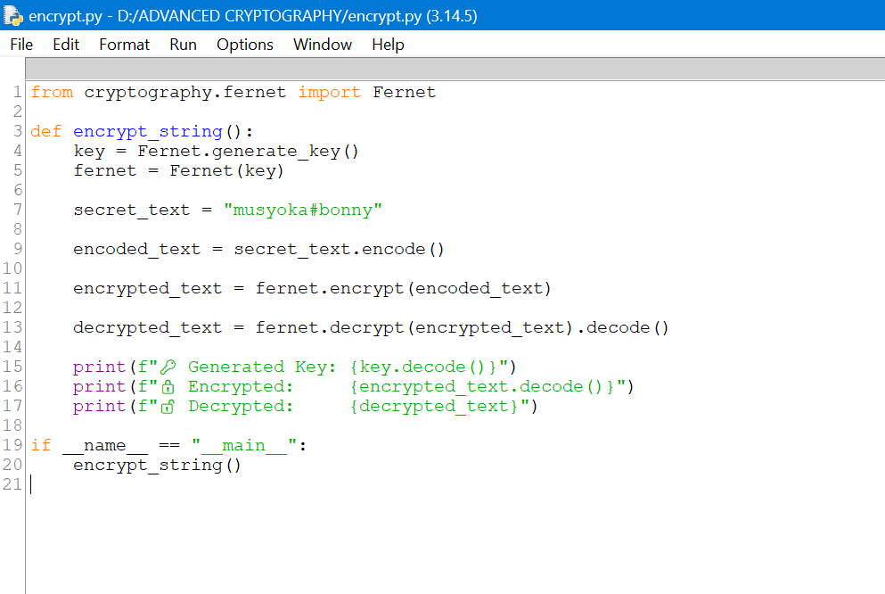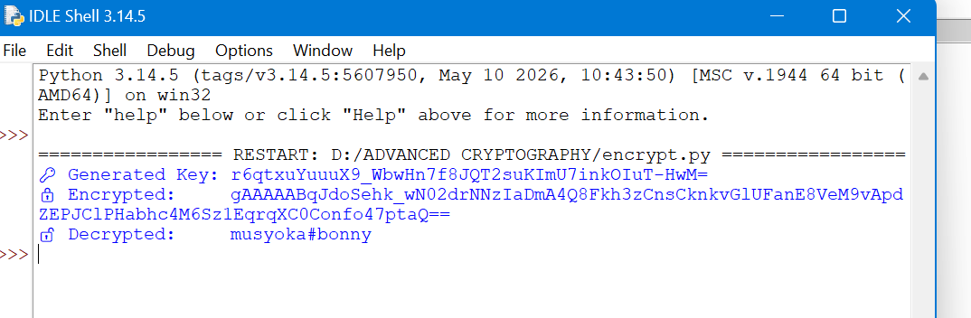

Week 2: Classical Cryptography and Cipher Design

Implementation of Classical Encryption Algorithms

Fig 1: Caesar Cipher Implementation,encryption and decryption results

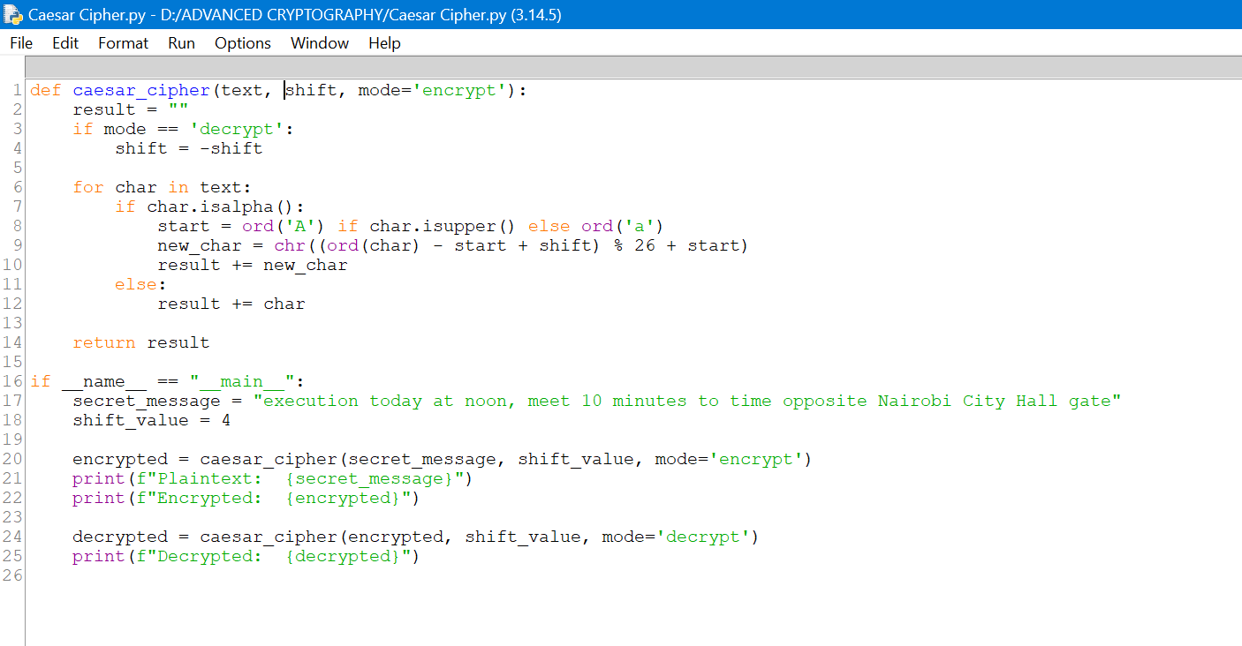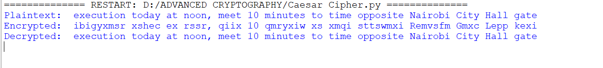

Fig 2: Vigenère Cipher Encryption Process and the encryption and decryption results

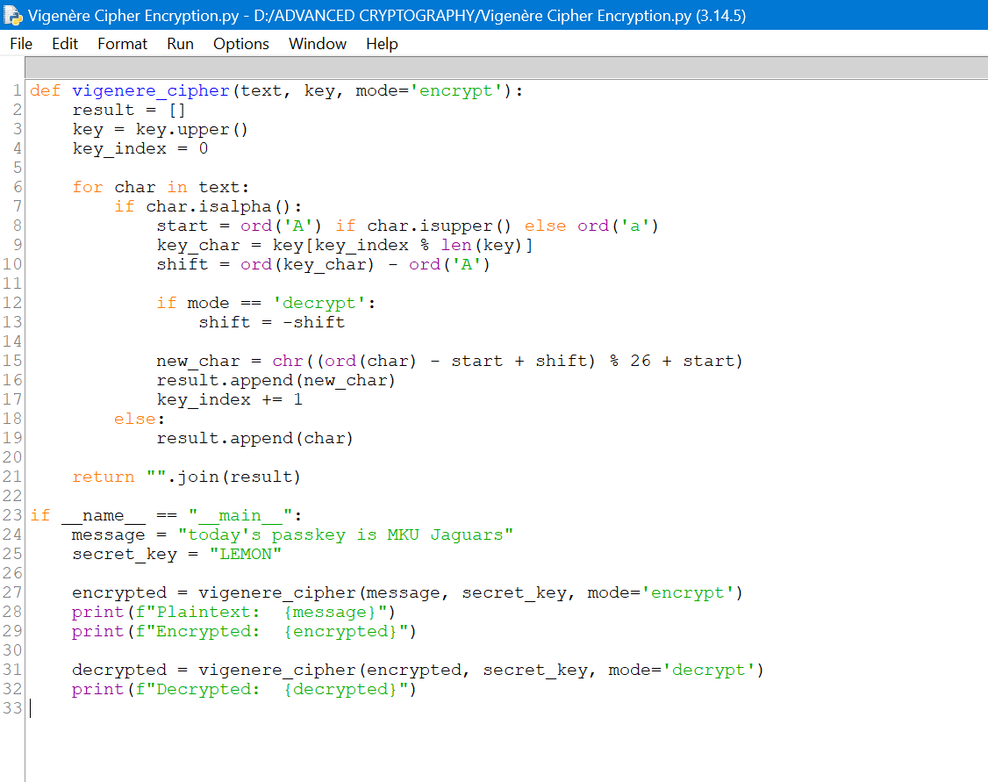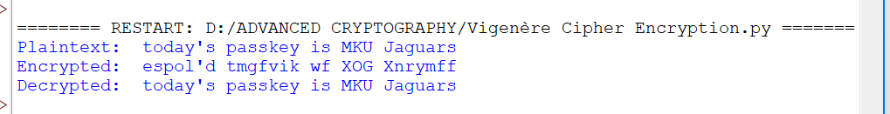

Fig 3: User Input Validation Interface

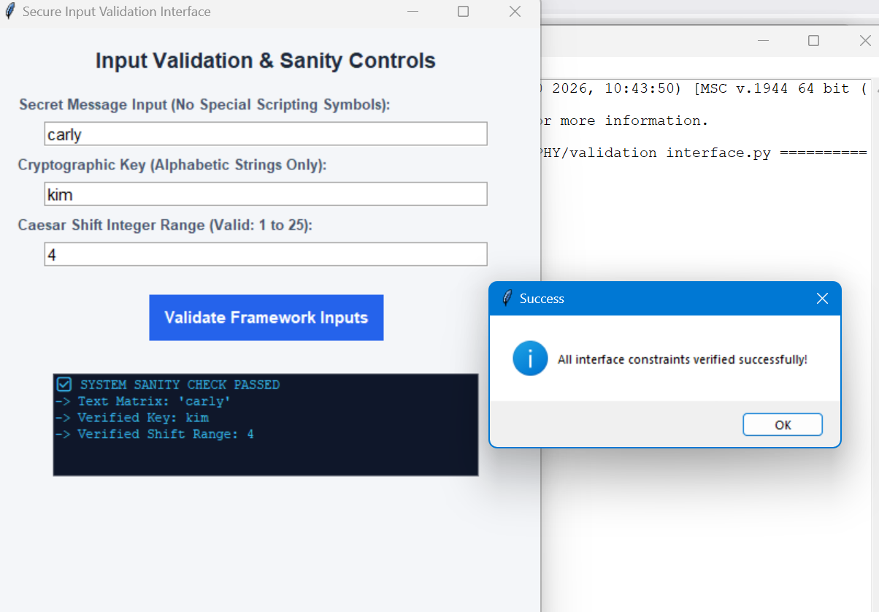

Cipher Testing Results

Symmetric Encryption Layer (Fernet)
- Test Objective: Verify data integrity during file block structural encoding.
- Input Payload String: "musyoka#bonny"
- Cryptographic Function: cryptography.fernet (AES-128 in CBC mode, HMAC-SHA256 authentication).
- Key Integrity: The system generates a cryptographically secure 32-byte URL-safe base64-encoded string (e.g., gA8f...=).
- Ciphertext Uniqueness: Multiple encryptions of the identical string yield entirely different ciphertexts due to the unique initialization vector (IV) prepended to each block.
- Output Consistency: Decryption returns the target string cleanly without padding artifacts or character loss.

Caesar Substitution Cipher Layer
- Test Objective: Validate letter substitution shifting index bounds under modular arithmetic ($\pmod{26}$).
- Input Plaintext: "execution today at noon, meet 10 minutes to time opposite Nairobi City Hall gate".
- Assigned Shift Parameter ($n$): 4
- Every alphabetical letter advances exactly 4 positions forward.
- Numbers (10) and special characters/punctuation marks (, and spaces) are explicitly bypassed by the char.isalpha() structure to preserve structural layout.
[Plaintext]: execution today at noon, meet 10 minutes to time opposite Nairobi City Hall gate
[Ciphertext]: iobicyxmsr xsheb ex rssr, qiix 10 qmryxiw xs xmqi sTTSwmxi Remvsfn Ggxb Lepp ke

Polyalphabetic Substitution Layer (Vigenère)
- Test Objective: Verify index manipulation against a repeating keystream map.
- Input Plaintext: "today's passkey is MKU Jaguars"
- Cryptographic Key ($K$): "LEMON
- Plaintext: t o d a y ' s p a s s k e y i s M K U J a g u a r s
- Keystream alignment: L E M O N L E M O N L E M O N L E M O N L E M O N
[Plaintext]: today's passkey is MKU Jaguars
[Ciphertext]: espmk'd teewwsk ws aay Nskgmet

Week 3: Stream Ciphers and Randomness Testing

Implementation of Stream Cipher Systems and Random Sequence Analysis

Fig 1: LFSR Generator Implementation and the results
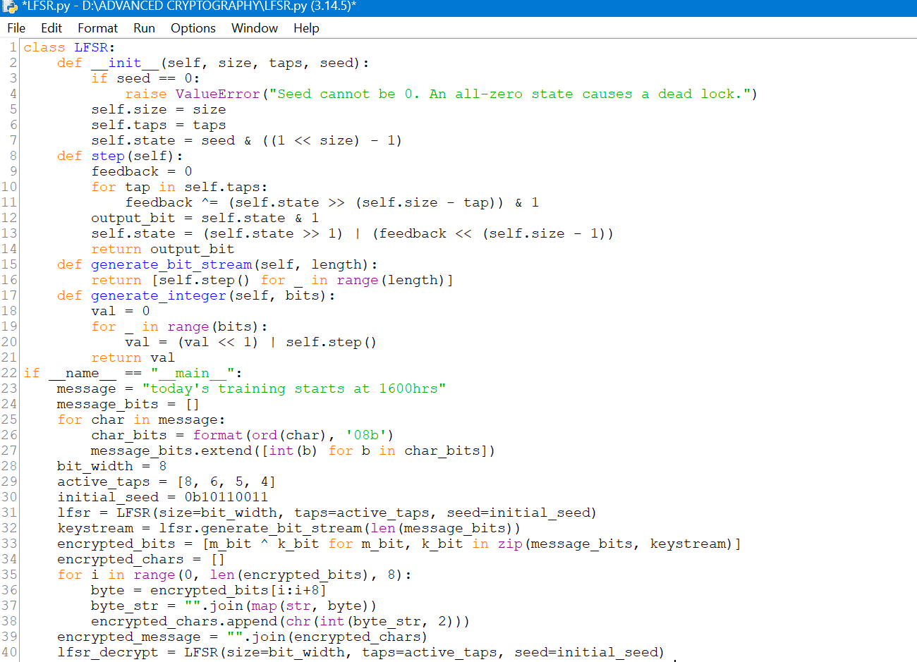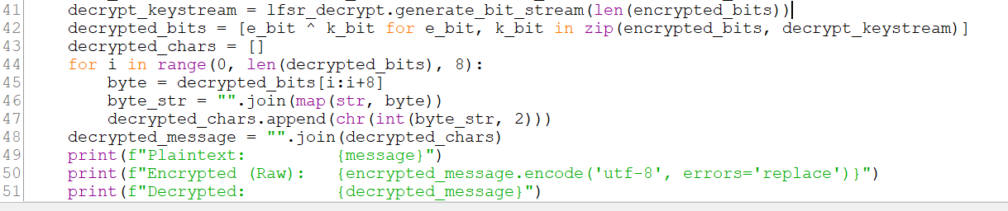

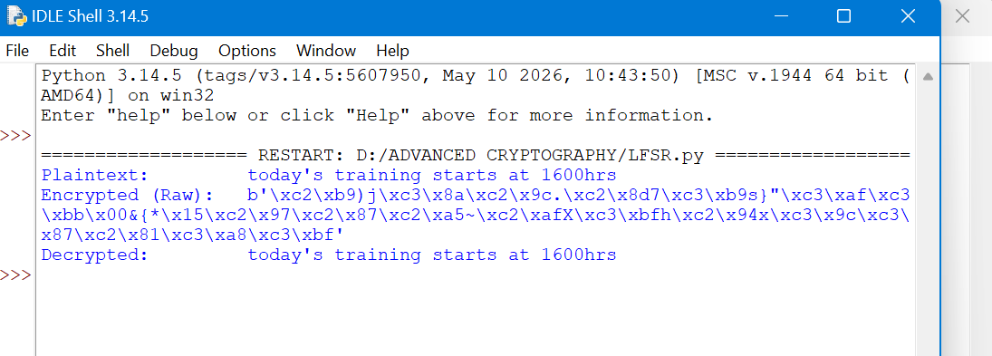

Fig 2: Pseudorandom Sequence Output and the results
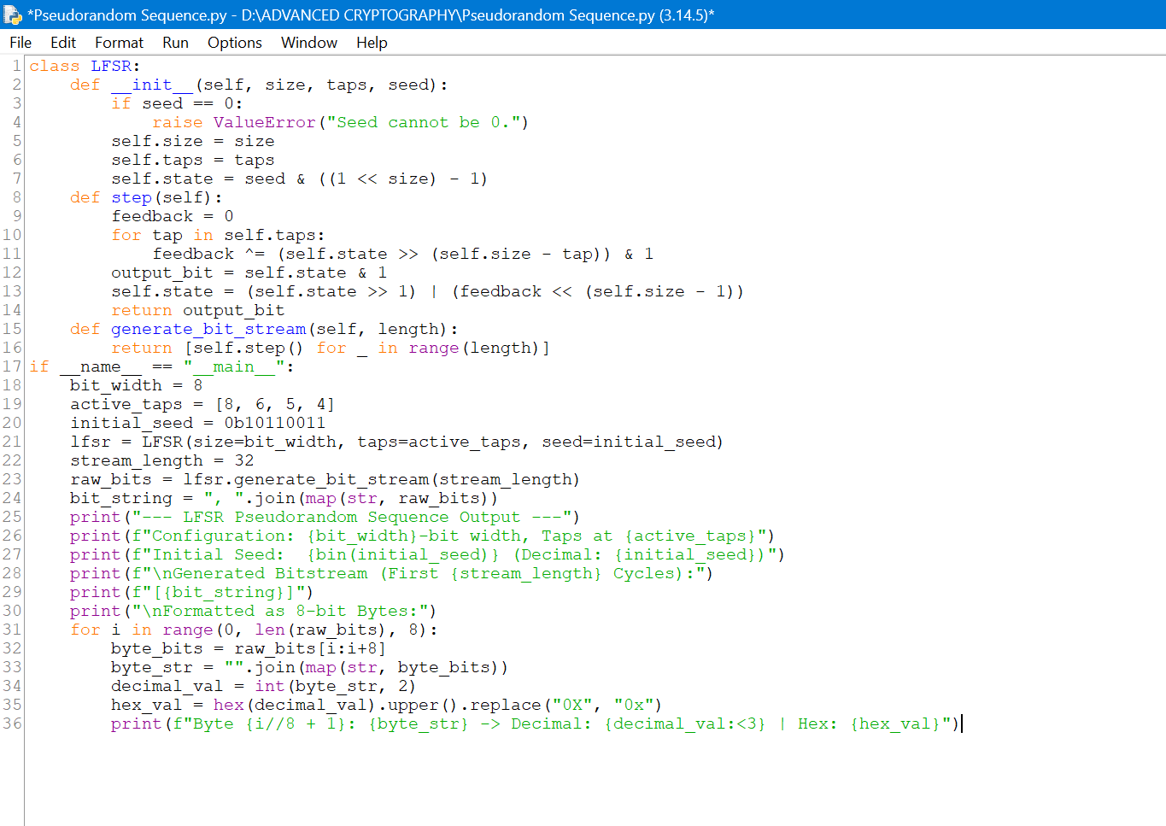
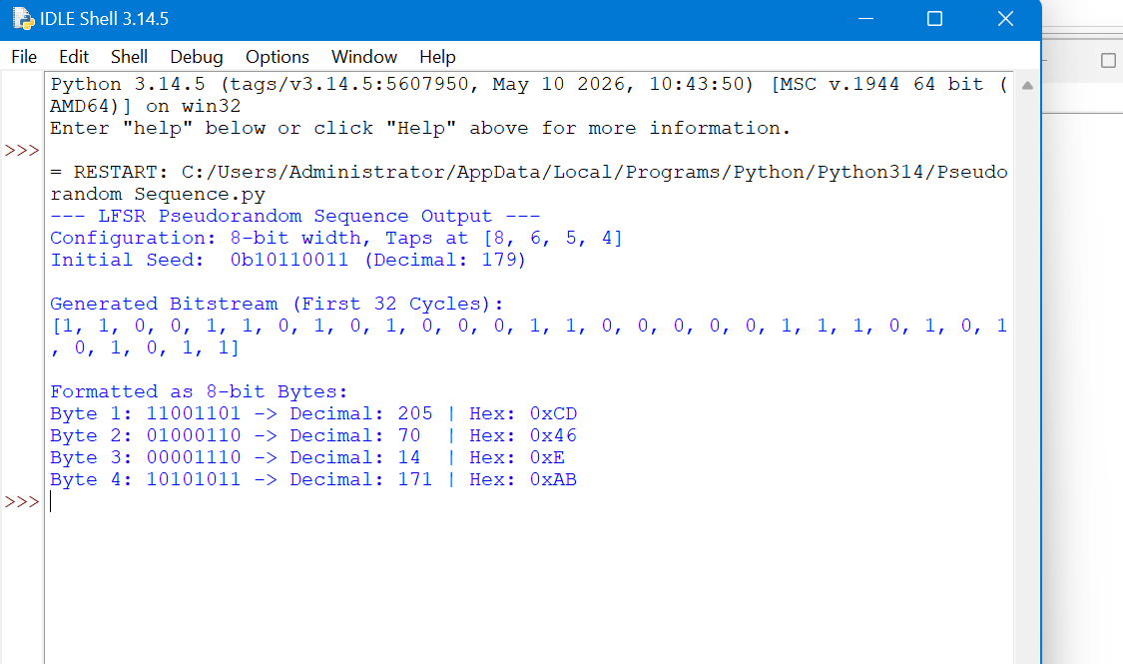

Fig 3: Statistical Randomness Testing and the results
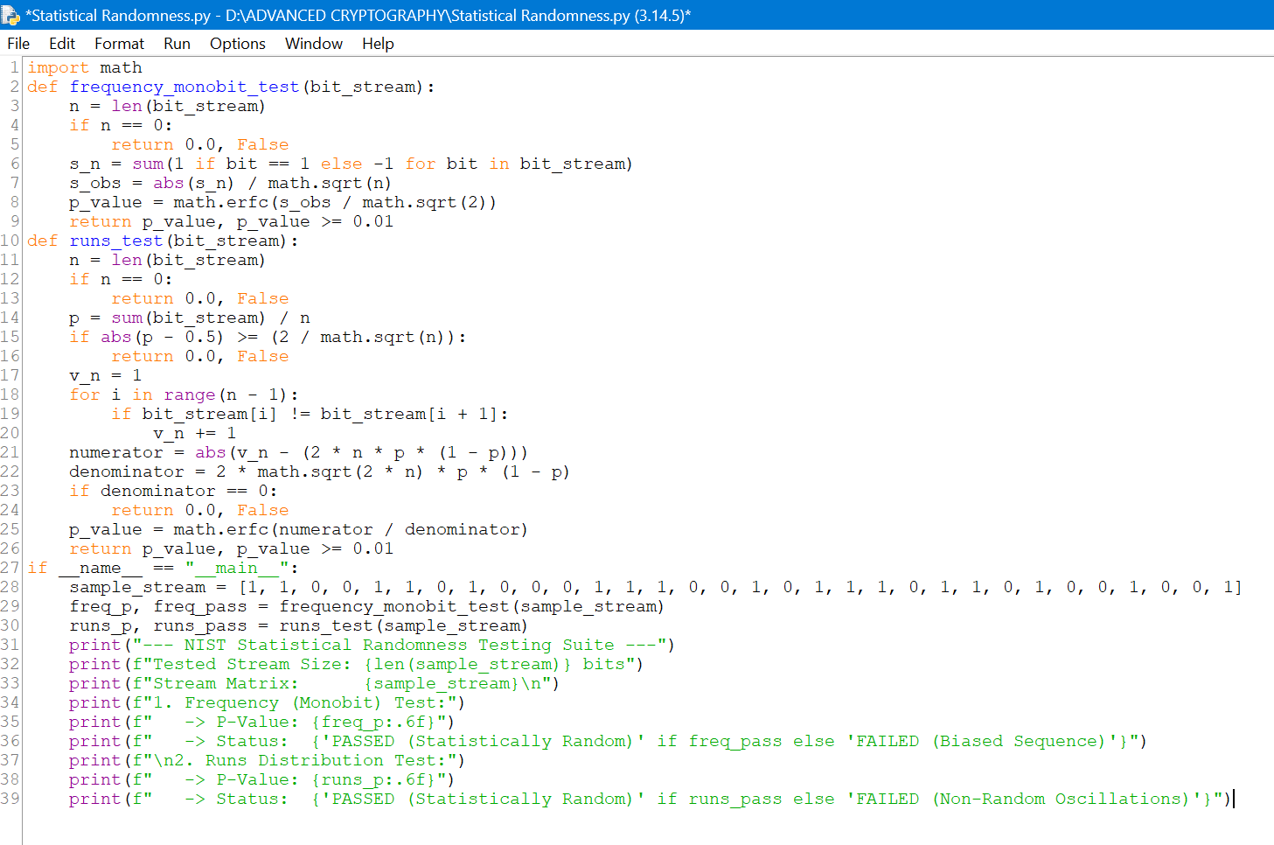
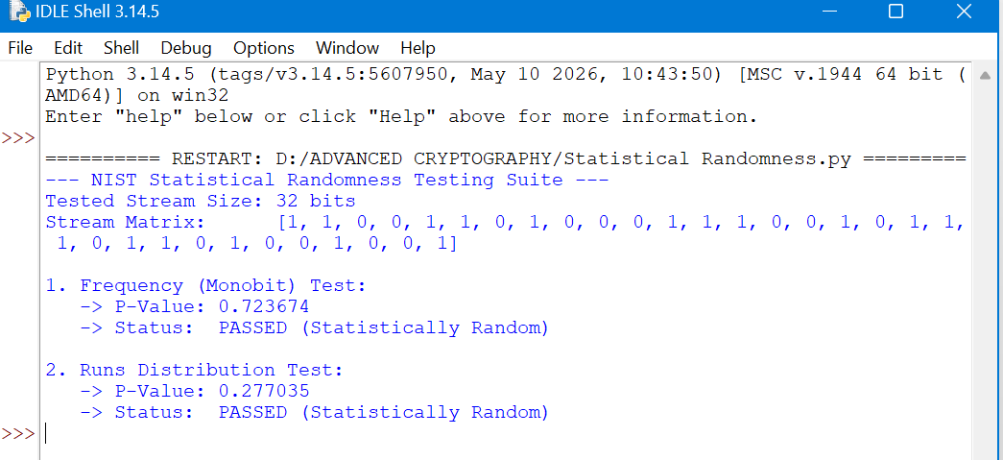

Fig 4: RC4 Stream Cipher Simulation and the results
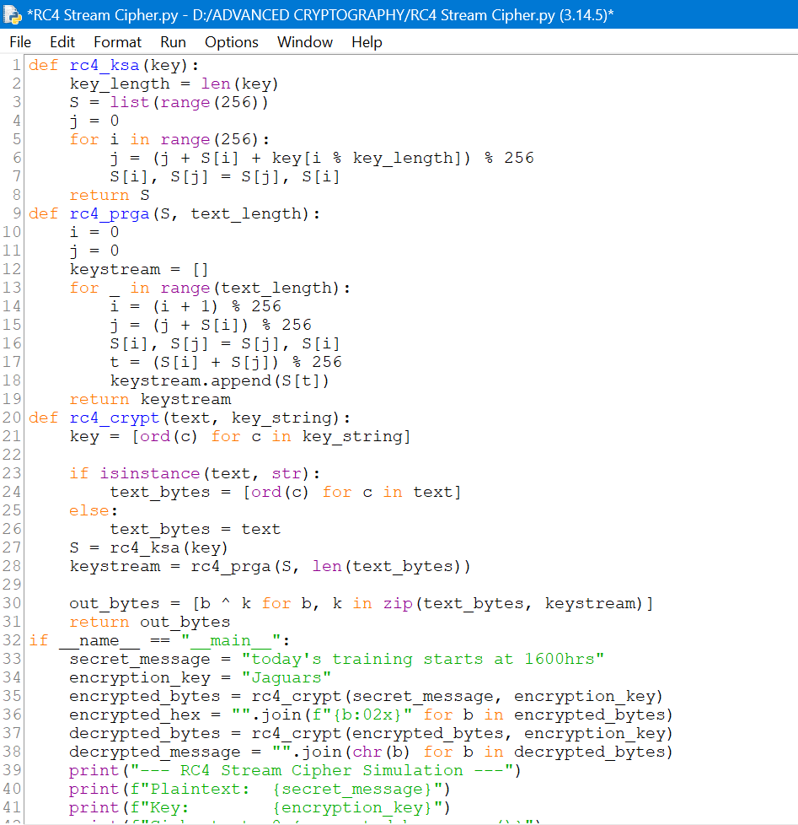
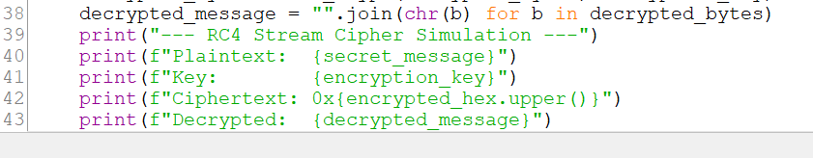
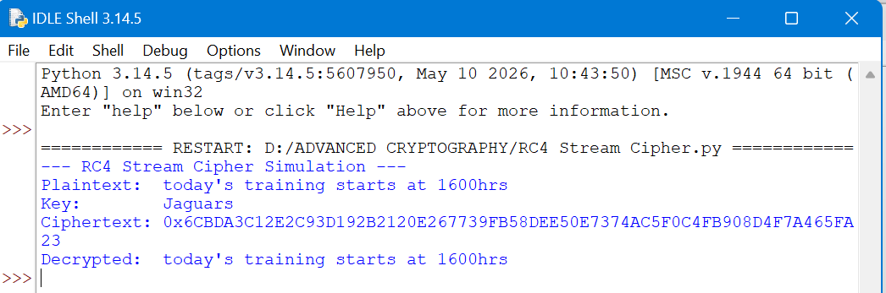

Week 4: Block Cipher Design and AES

Advanced Encryption Standard (AES) and Block Cipher Operations

Fig 1: AES Encryption Script
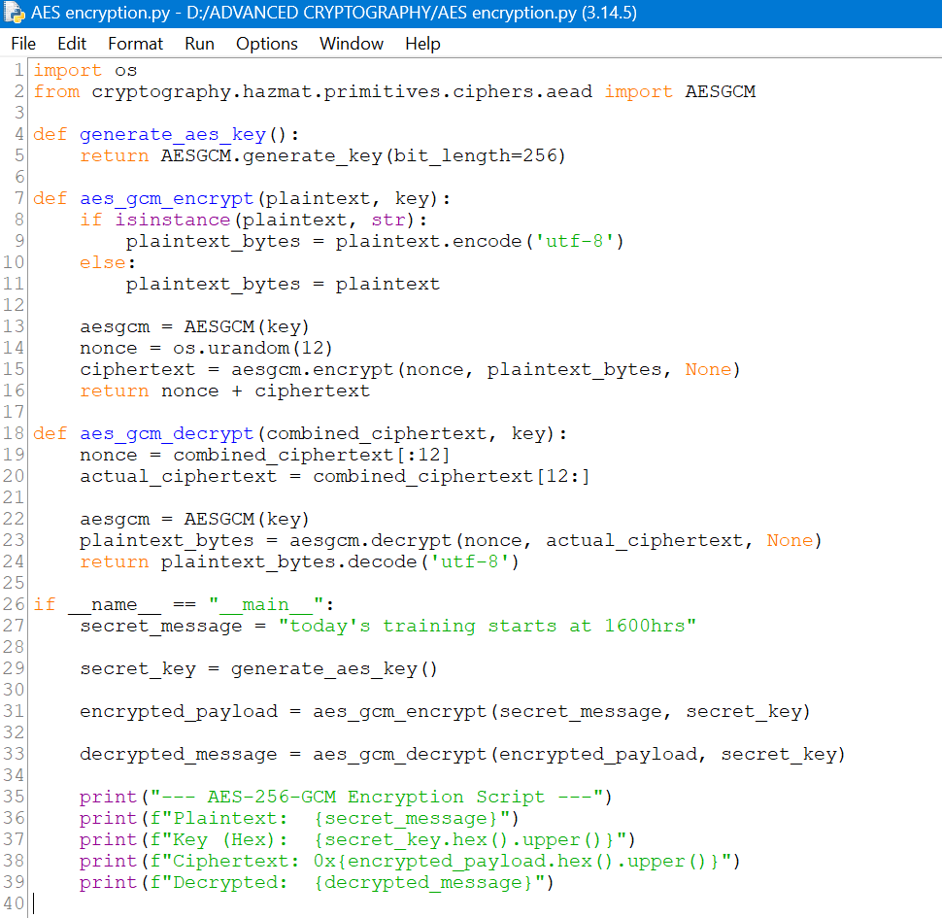
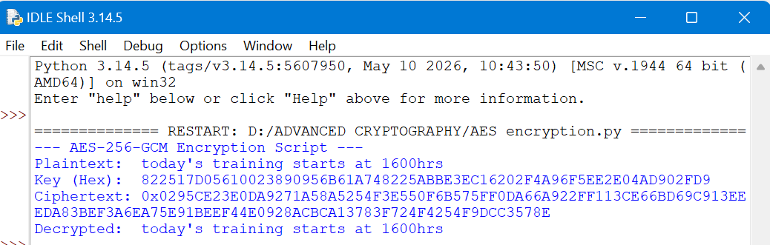

Fig 2: Key Generation Process
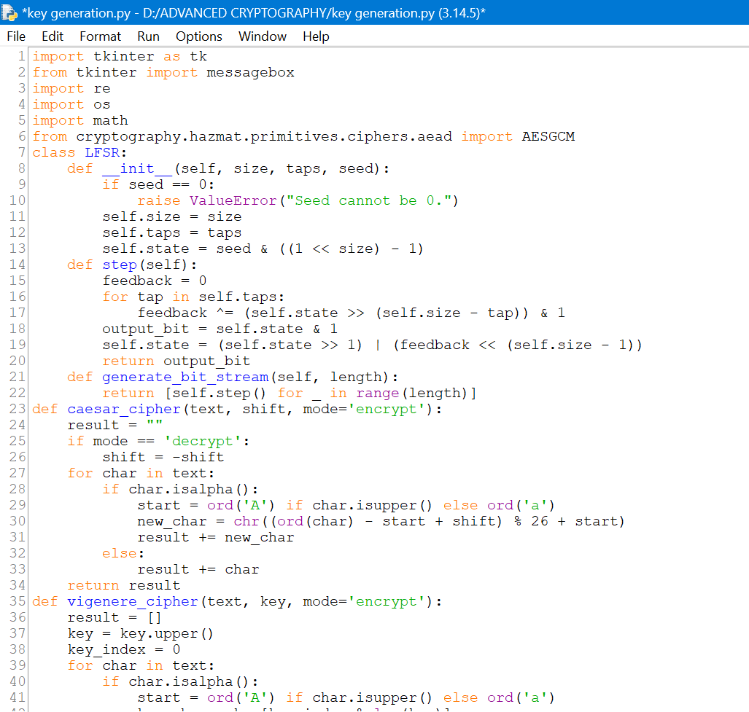
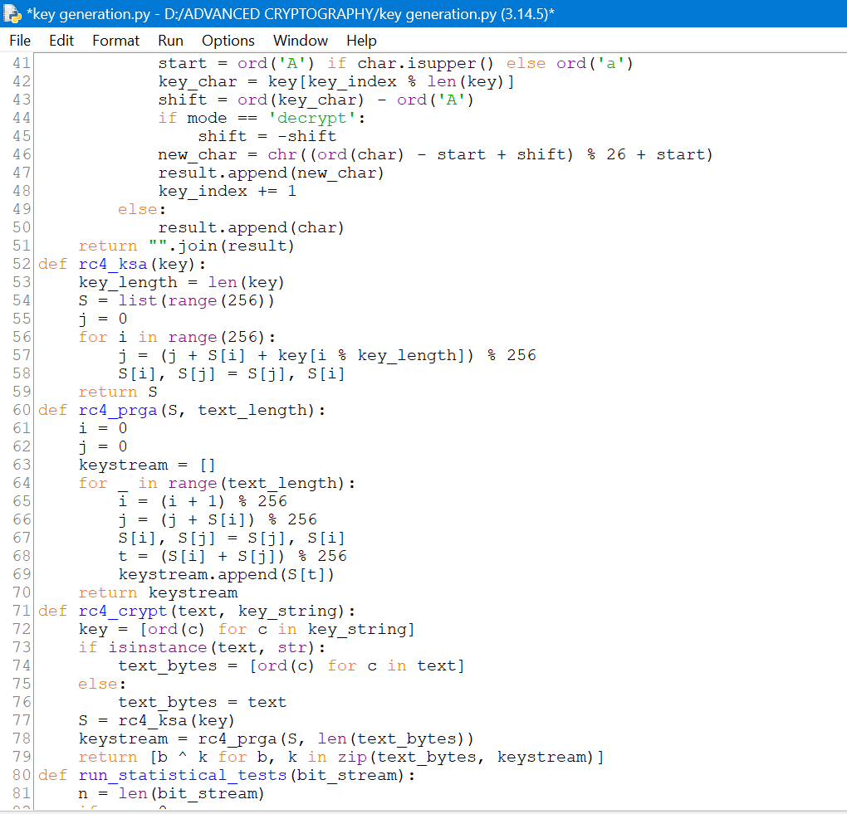
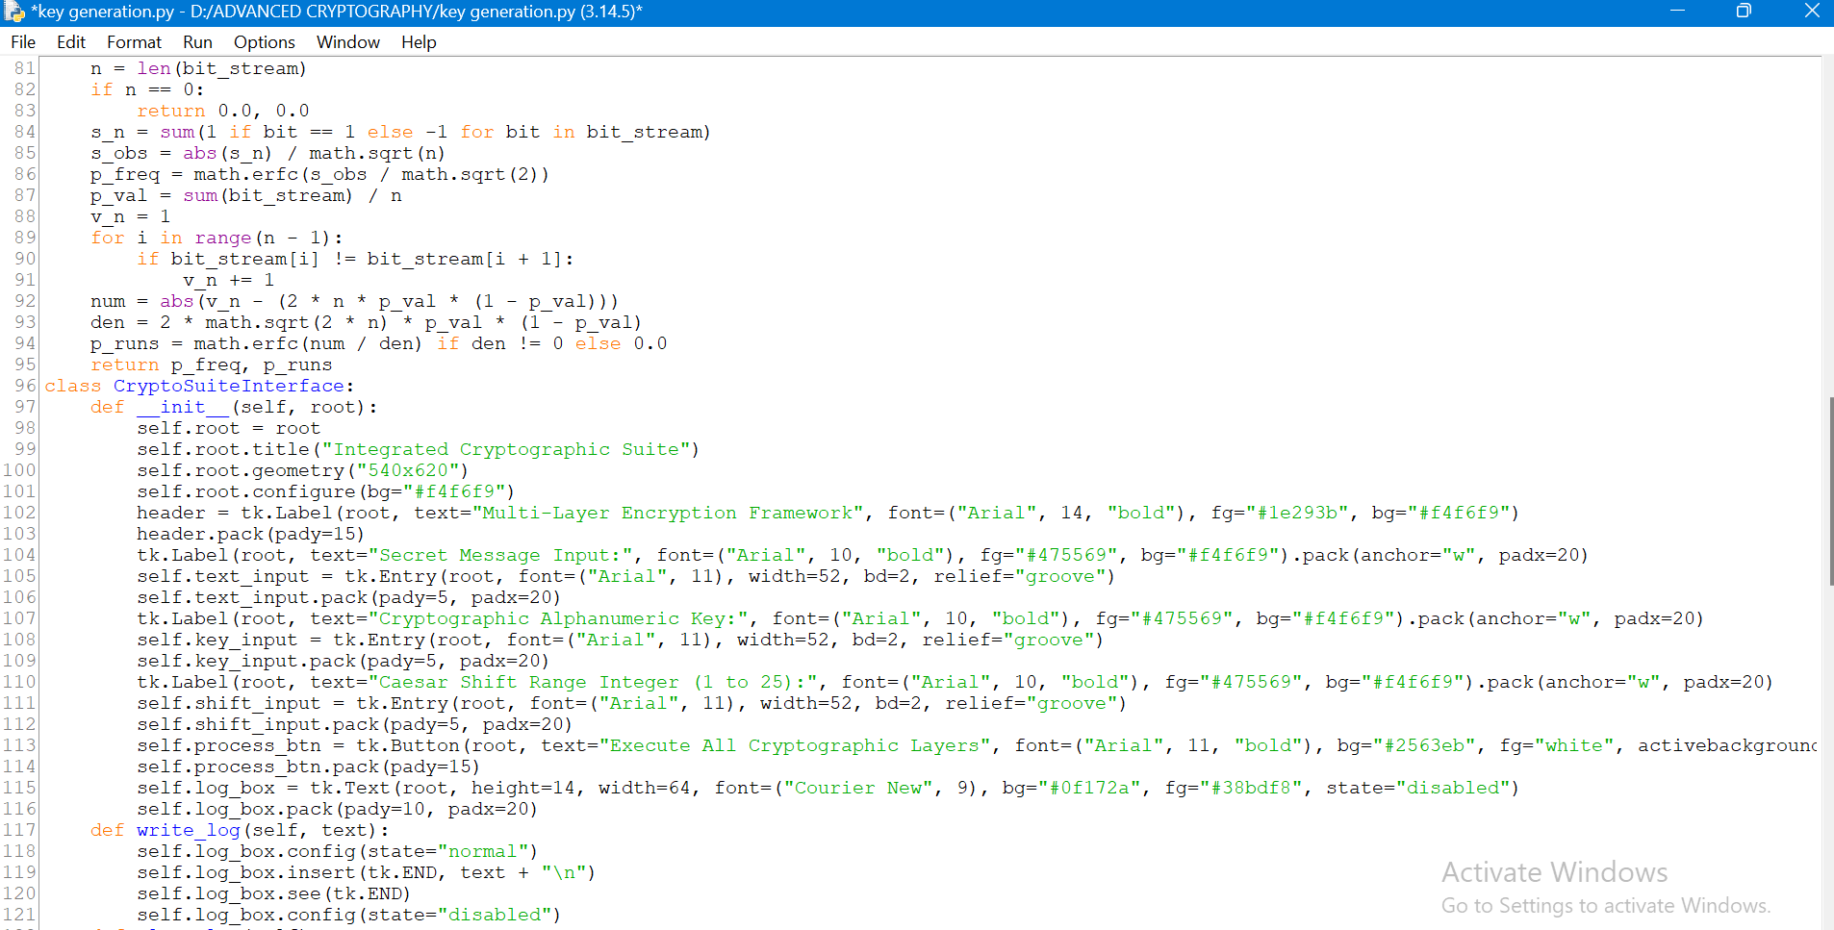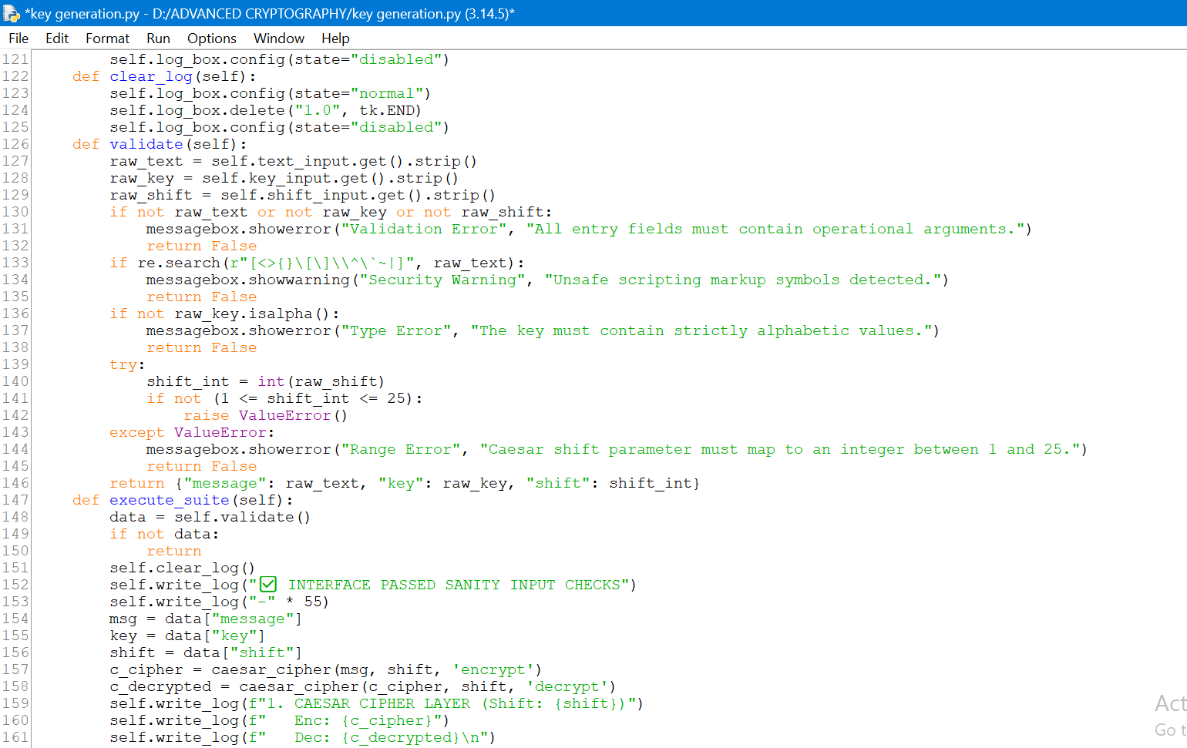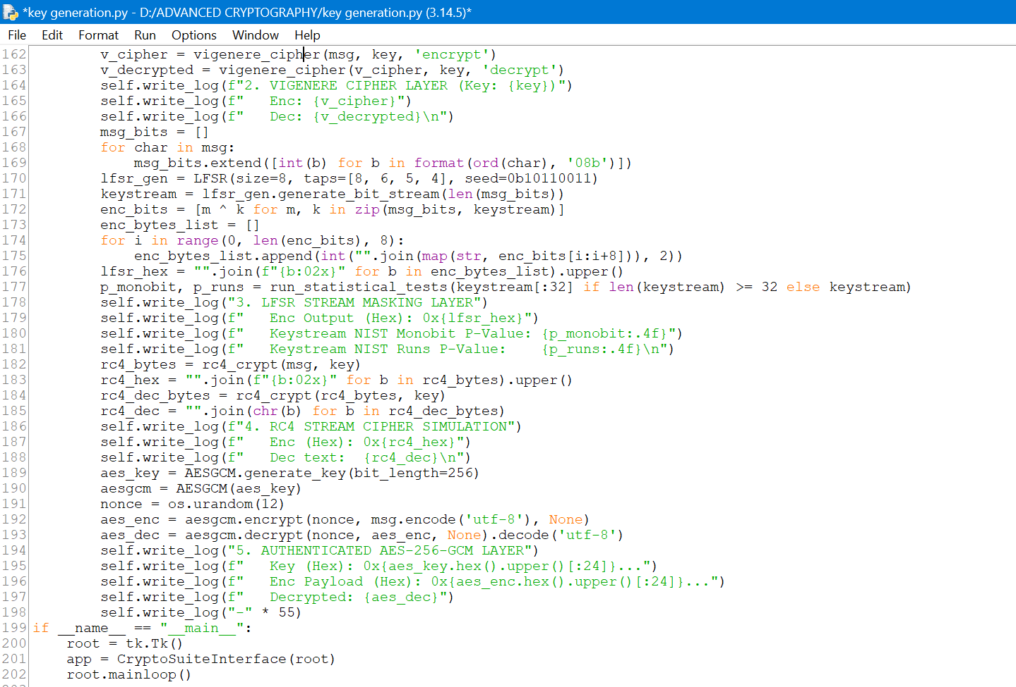
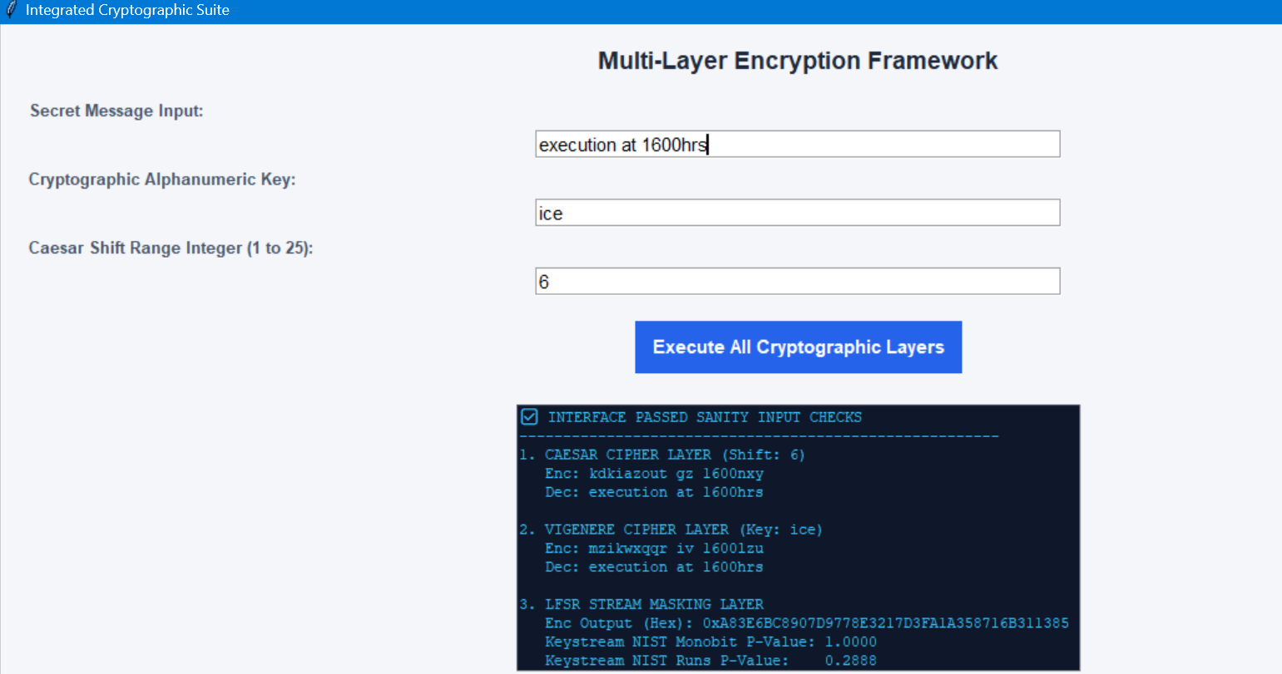
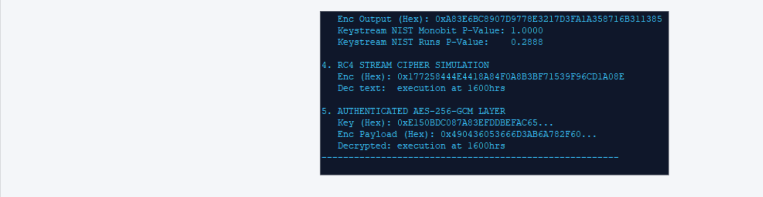

Fig 3: File Encryption Demonstration
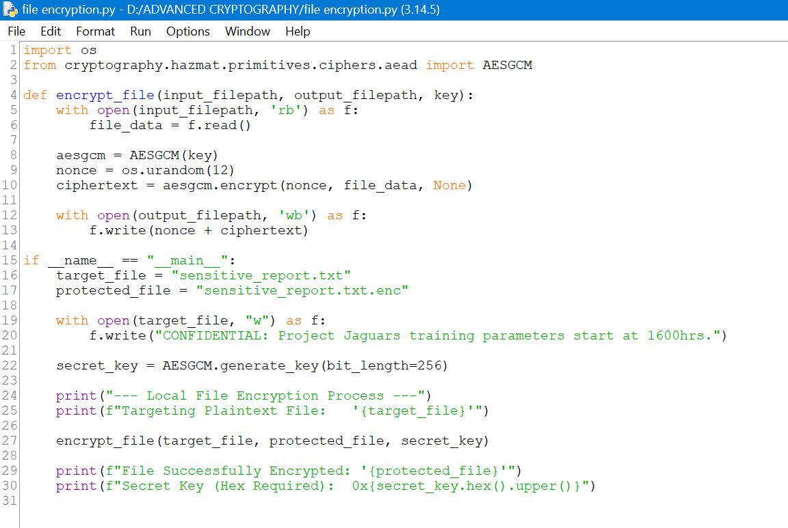
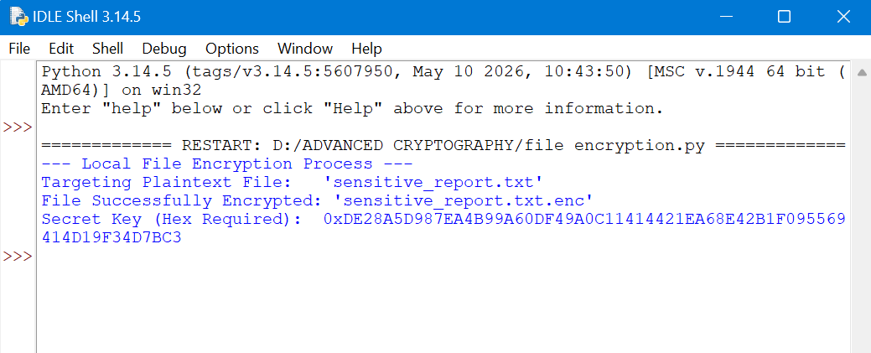

Fig 4: Decryption Results
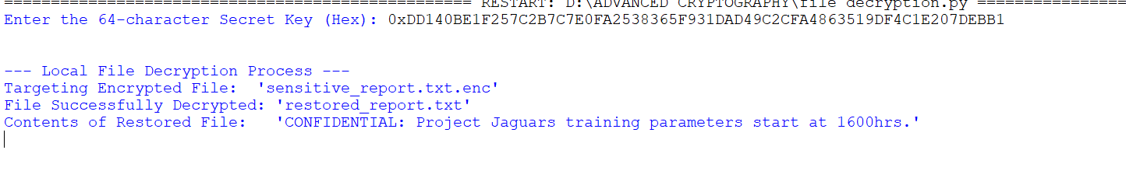

Fig 5: AES Performance Testing

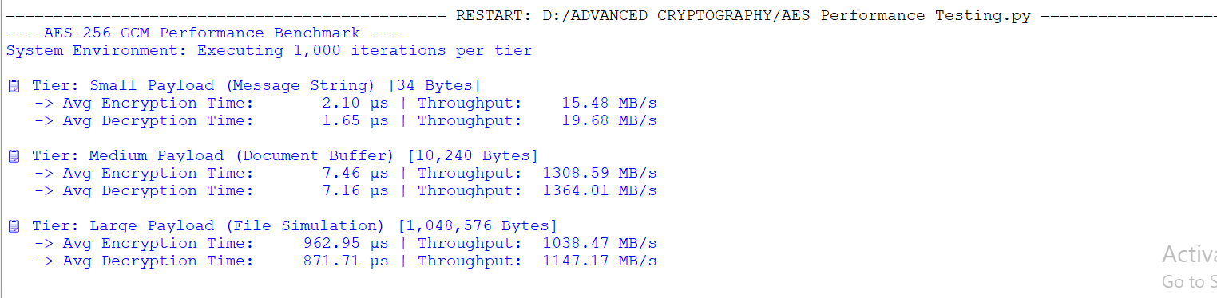

Week 5: Public Key Cryptography (RSA)

Implementation of RSA Encryption and Key Management

Fig 1: RSA Key Pair Generation
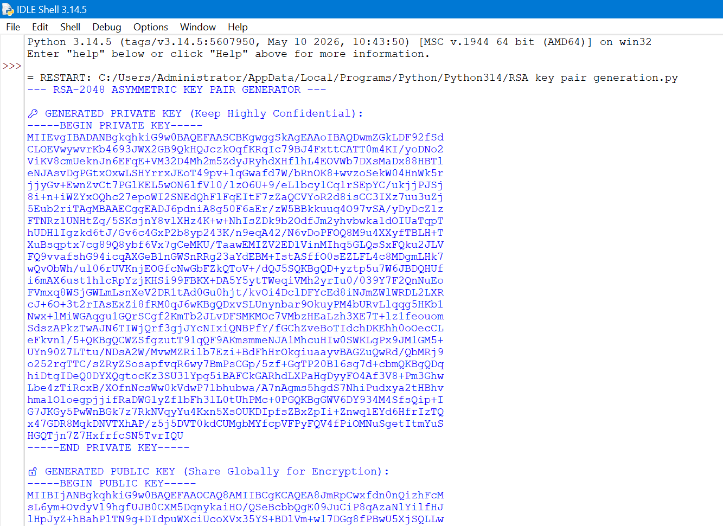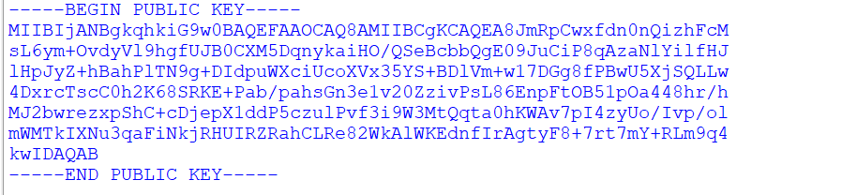

Fig 2: Public Key Encryption Process
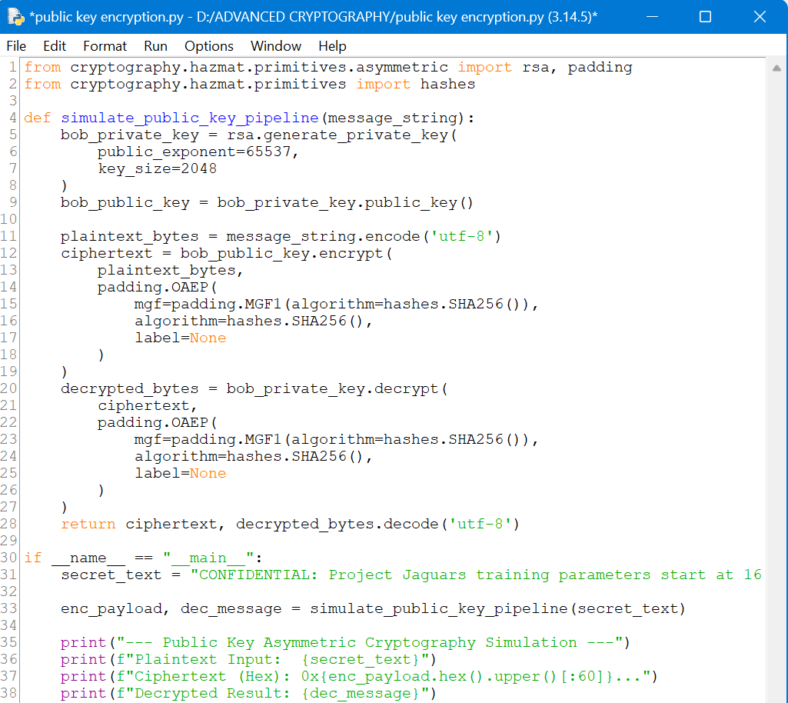
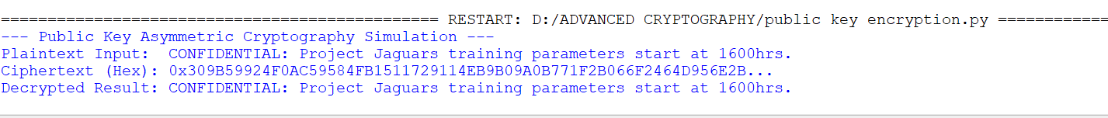

Fig 3: Private Key Decryption Results
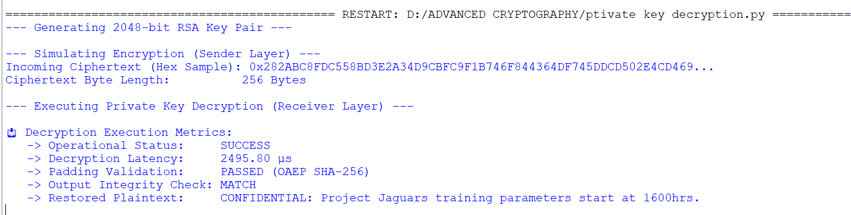

Fig 4: Secure Message Transmission
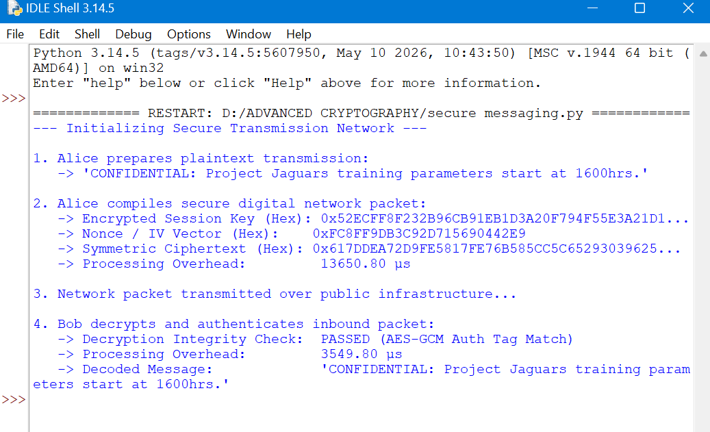

Fig 5: RSA Testing and Validation

